St. Alexander Catholic School Council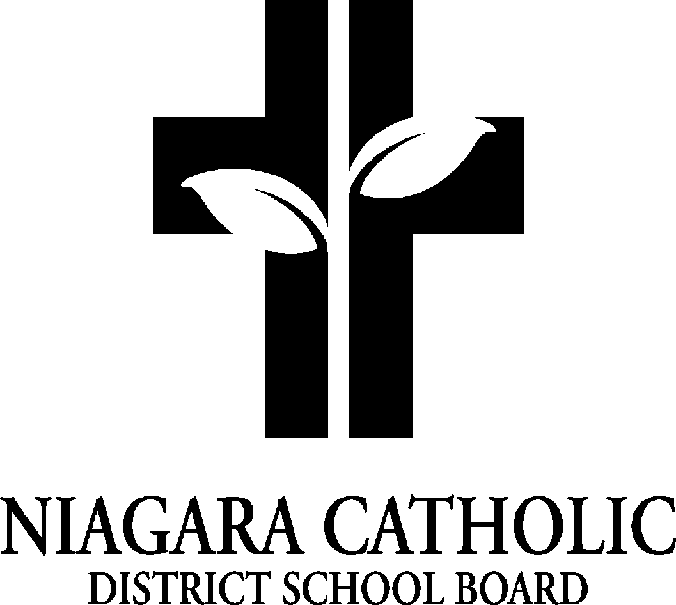

AGENDA

Wednesday, November 26, 2024 - 5:30pm

1. Prayer: Mrs.Pozzobon
2. Role Call

Present: V. Jaski, C. Carrier, A. Tallman, J. Jones, A. Frederick, S. Sutherland, S. Musso, K. DeDivitiis, A. Miotto, L. Bader, Pollecilla, T. Principi, C.Pozzobon & M.Venzon

Regrets: J. Della Ventura

Absent:

1. Chair Report

i) Food Days - Pita Pit, Pizza, Subway, Hotdog day

* positive feedback from parent group
* Hot dog day donations were made to the community

ii) Fundraising Update - Halloween Dance-a-thon / Glow Sticks

Dieleman fundraiser

* $1327.00 profit
* Posted link--on FB and it helped with the fundraiser
* Message will go home to parents about pick up date

Purse Bingo - dates, license, etc…

* start to collect donations of purses early
* More advertisement

1. Principal’s Report
2. Policy vetting
3. Christmas Concert at St. Alexander - December 11th, 2024 - Afternoon (12:30) and Evening performance (6:30pm)
4. Kindergarten Christmas - December 5th
5. School Reconciliation in Gym - was November 20th
6. Rosary Club, Wednesday mass at Church, - Rosary with Grades 5-8 in classrooms
7. Christmas Food Drive - information sent to all parents
8. Notre Dame Open House for Grade 8’s 6:30pm on Jan. 14th, 2024
9. Shrove Tuesday March 4th - Pancakes
10. Grade 8 Graduation - popcorn sales for grad
    1. all money from popcorn sales goes to pay for grade 8 graduation
11. Other happenings: Grades 3-6 to Elf - Dec. 10, Grades 3-4 to ND for Christmas Display (Dec 13), Advent Services x4, Christmas Choir performs at the Seaway Mall (Dec 13).

5. School Improvement / Staff Report

EQAO scores for St. Alexander - what they mean

* compared to NCDSB and Ontario

DOT scores and what we are doing as a learning team

* Looking at those students that are close to the next level (2.8, 2.9) making them our target students in tier 2 small group instruction.

EQAO Sample test -

* Parents as students! Parents log into Eqao and try the Grade 3 Sample Test and share their experience and findings.

6. Treasurer’s Report

St. Alexander Catholic School

Tuesday, November 26, 2024

Financial Statement

General Fundraising

Fundraising Activities Expense Revenue Balance

| General Fundraising | 3,689.00 | 6,440.00 | 2,751.00 |
| --- | --- | --- | --- |
|  |  |  |  |
| Food Days | 12,199.02 | 16,276.50 | 3,048.75 |
| Dance-a-thon | $281.37 | 4,660.00 | 4,378.63 |

| Overall Totals |  |  | 10,178.38 |
| --- | --- | --- | --- |

Next Meeting Date: Tuesday, January 28, 2025 - 5:30pm

Closing Prayer: